**Name(s):** Marzuk Rashid, Snehil Chopra

**Netid(s):** marzukr2, snehilc2

**Mean Reward Reached :** 15.66

**Uploaded Saved Double DQN Model on Compass : Yes**

**Uploaded your Agent.py and Agent_double.py file on Compass : Yes**

**Plot of Mean Evaluation Reward for DQN:**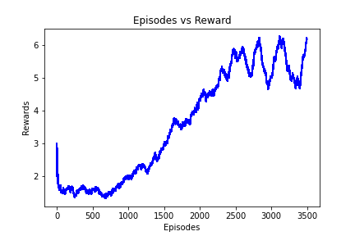

**Plot of Mean Evaluation Reward for Double DQN (please run both plots for the same number of episodes):**

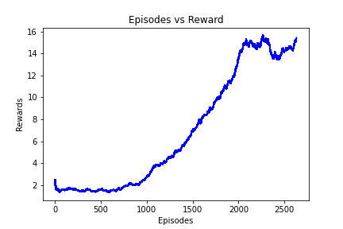

**Provide a few sentences of analysis between the differences between DQN and Double DQN: The theory behind Double DQN is that using a separate neural network as a target network will stabilize learning because we don’t use the same network to both select and evaluate actions. The thought is that using the max operator on the same network will push the Q values higher and higher—leading to a systematic overestimation. Our plots of the Mean Evaluation Reward support this hypothesis as it is apparent that the curve for Double DQN has much lower variance than that of DQN.**

**Extra Credit:**

1. What games did you apply the extra credit to?
2. What other algorithm did you use? Explain and cite all your sources. Any issues you got in training your new algorithm.